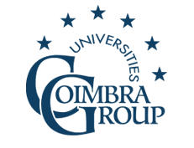
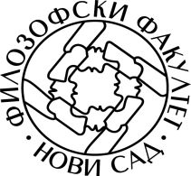


International Coimbra Group Summer School on European Multilingualism

Faculty of Philosophy, University of Novi Sad, 7th - 14th July 2018

Novi Sad - European Youth Capital 2019 and European Capital of Culture 2021

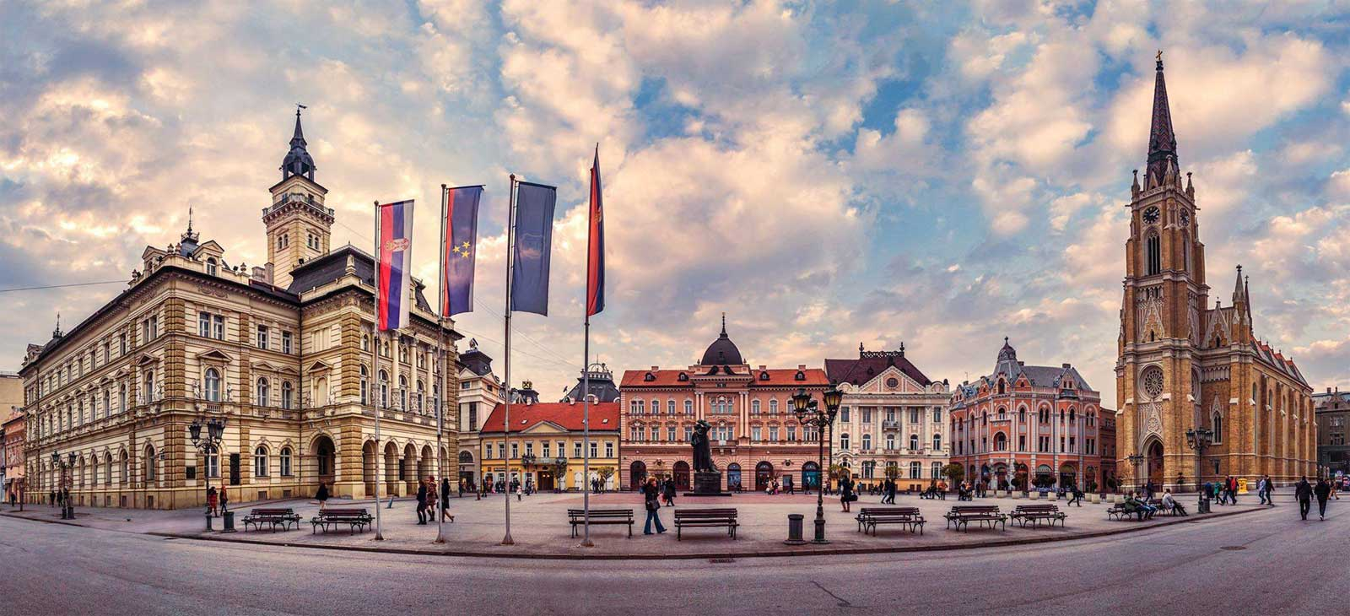

Practical information

Accommodation: to be arranged by the participants themselves in Novi Sad

A list of suggested hotels and hostels + Airbnb:

Hotels:
Park - http://www.hotelparkns.com/en/
Vojvodina - http://www.hotelvojvodina.rs/
Mediteraneo - http://hotelmediteraneo.rs/
Voyager - http://www.voyagerns.co.rs/
Zenit - http://hotelzenit.co.rs/
Centar - https://hotel-centar.rs/homepage-1/
Putnik- http://www.hotelputnik.rs/

Hostels:
Downtown - http://hostelnovisad.com/, City - http://www.cityhostel.rs/,

Sova - http://www.hostelsova.com/, Kutak - http://www.hostelkutak.com/en/
Centar - http://www.hostelcentarnovisad.com/en/

Airbnb : https://www.airbnb.fr/s/Serbia

Students hosts from Novi Sad University offering free accommodation for student coming from Coimbra Group universities: contact Anja Mitić anjamitic98@gmail.com

Cultural program: Exit Festival - https://www.exitfest.org/sr (12th- 16th July 2018)

Useful information:
UNS: https://www.uns.ac.rs/images/doc/medjunarodna/UNS_Ultimate_Guidebook.pdf
Tourist Organization of Novi Sad: http://novisad.travel/en/

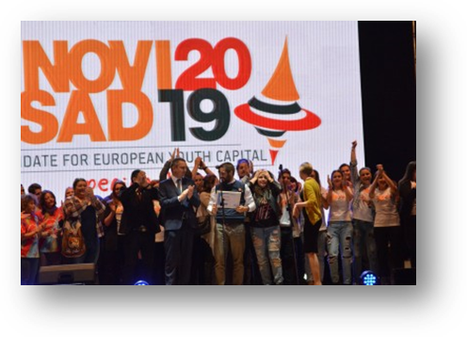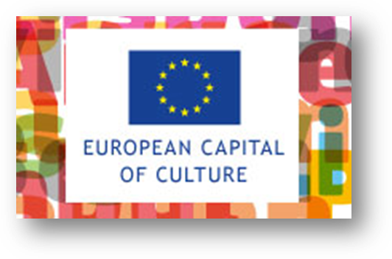

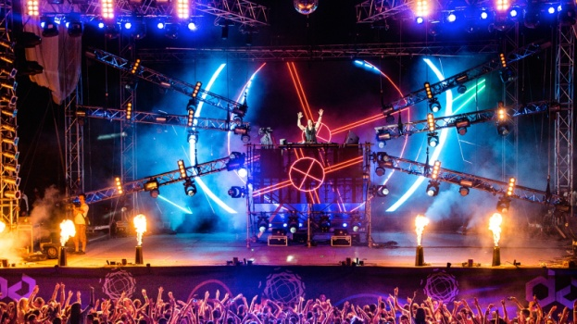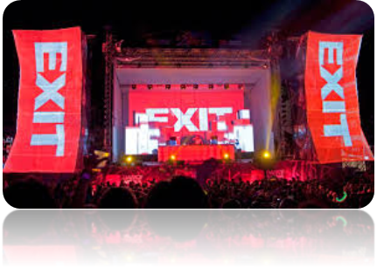

Founded in 1985, the Coimbra Group (CG) is an association of long-established European research universities of high international standard: http://www.coimbra-group.eu

