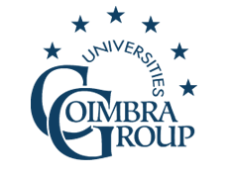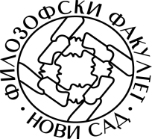

International Summer School on European Multilingualism

Coimbra Group & University of Novi Sad

Faculty of Philosophy, University of Novi Sad, 7th - 14th July 2018

Faculty of Philosophy
Dr Zorana Đinđića 2,
Novi Sad 21000
Serbia

Registration form

- Language group you wish to enroll in :
- German-Serbian
- French-Serbian
- Italian-Serbian
- Spanish-Serbian

SURNAME:

First name:

Address:

Town:

Country:

E-Mail:

Study level:

Home university:

You can pay the registration fees in your bank (see the instructions for payment) or at a bank in Novi Sad.

