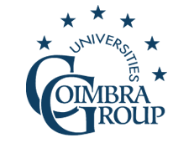 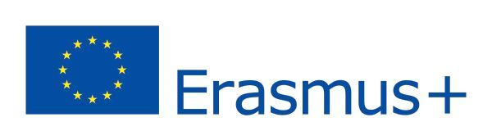

***International Summer School on European Multilingualism***

**Faculty of Arts and Humanities, University of Coimbra, 23 - 27 June 2025**

**Faculty of Arts and Humanities**

**Largo da Porta Férrea**

**3004-530 Coimbra**

**Portugal**

**Registration form to be sent to** [**dri.cooperacao@uc.pt**](mailto:dri.cooperacao@uc.pt)

**from 21 April to 16 May 2025**

* **Language group you wish to enroll in:**
* German
* French
* Italian
* Spanish

SURNAME:

First name:

Address:

Town:

Country:

E-Mail:

Study level:

Home university: