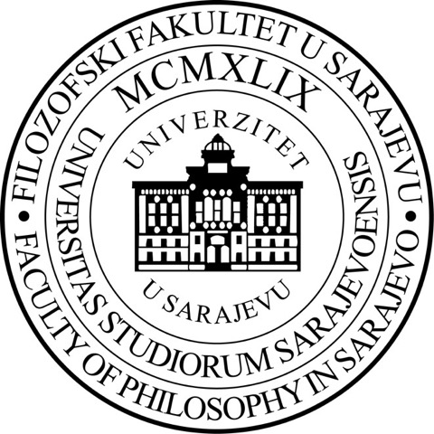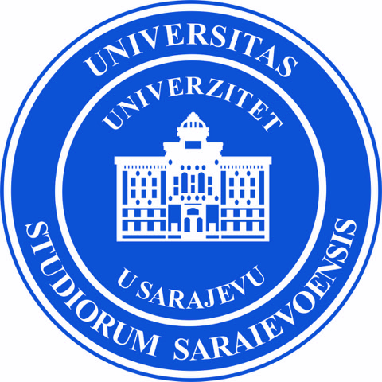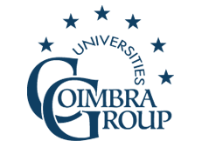

International Summer School on European Multilingualism

University of Sarajevo & Coimbra Group

Faculty of Philosophy, University of Sarajevo, 30th June - 6th July 2019

Faculty of Philosophy
Franje Račkog 1,
Sarajevo 71000
Bosnia and Herzegovina

Registration form

- Language group you wish to enroll in:
- French - B/H/S
- German - B/H/S
- Italian - B/H/S
- Russian - B/H/S
- Spanish - B/H/S

SURNAME:

First name:

Address:

Town:

Country:

E-Mail:

Study level:

Home university:

Please send your Registration form to: selma.djuliman@ff.unsa.ba

